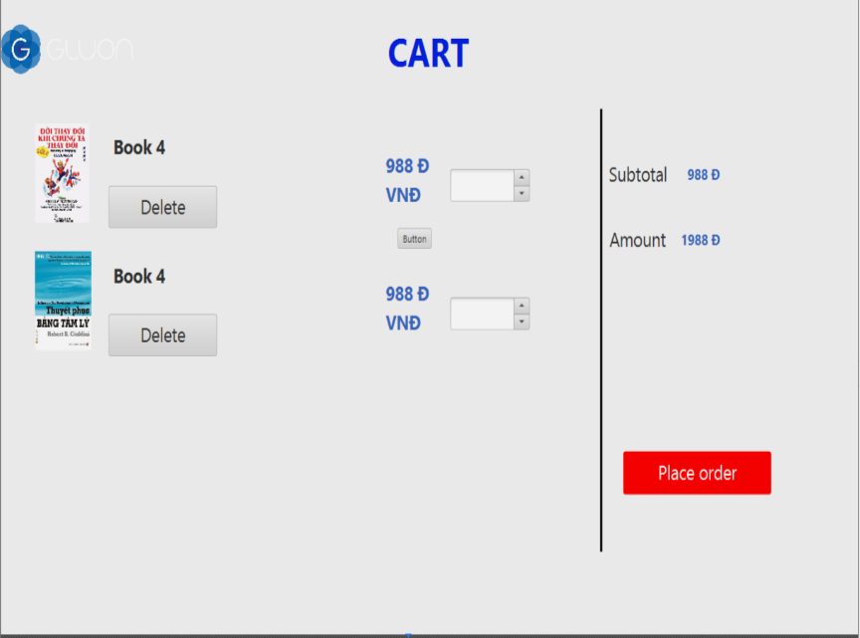 | Control | Operation | Function
 | Area for displaying the subtotal | Initial | Display the subtotal
 | Area for display items in the cart | Initial | Display the media with the corresponding infomation
 | Place order button | Click | Display the Delivery form
 | Delete button | Click | Remove the item from the cart

Screen name | View cart
Item name | Number of digits(bytes) | Types | Field attribute | Remarks
Media title | 50 | Numeral | Black | Left-justified
Price | 20 | Numeral | Blue | Right justified
Subtotal | 20 | Numeral | Blue | Left-justified

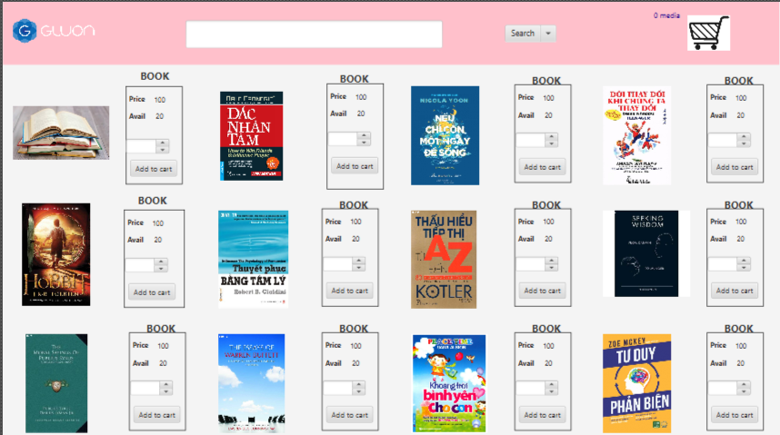 |  |  | Control | Operation |  | Function
 |  |  | Area for displaying the item | Initial |  | Display the list item
 |  |  | Logo Cart | Click |  | Display cart
 |  |  | Input text | Click |  | Client enter search ìnormation
 |  |  | Dropdown box | Click |  | Client choses search option type
 |  |  | Add to cart button | Click |  | Add the item from the cart
Screen name | Screen Home
Item name | Number of digits(bytes) | Types |  |  | Field attribute |  | Remarks
Media title | 50 | Numeral |  |  |  |  | Left-justified
Price | 20 | Numeral
Subtotal | 20 | Numeral
Avail | 20 | Numeral
Input text | 100 | String

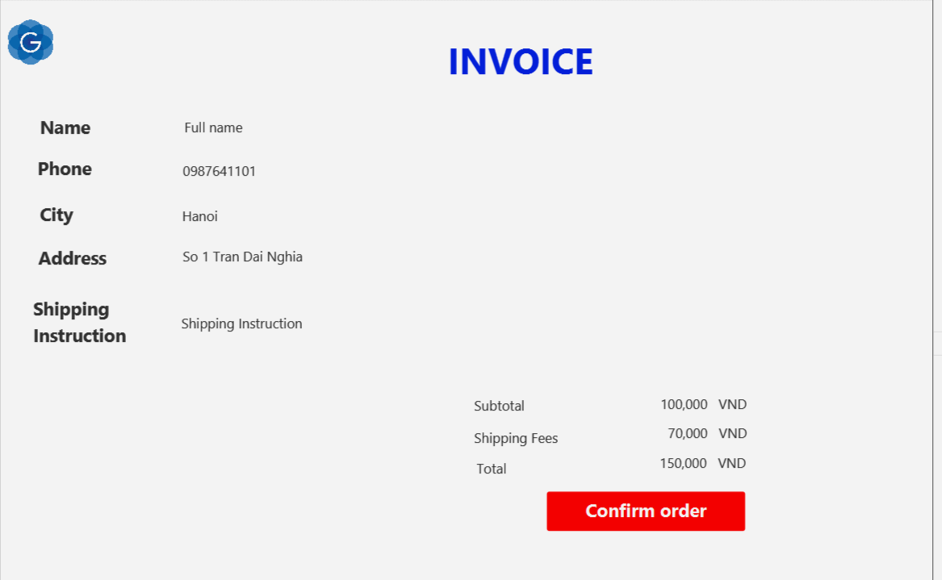 | Control | Operation | Function
 | Area for displaying the information Client | Initial | Display the information Client
 | Area for displaying the Subtotal | Initial | Display the subtotal, shipping fees and total
 | Title | Initial | Display name
 | Confirm button | Click | Confirm the voice

Screen name | View Voice
Item name | Number of digits(bytes) | Types | Field attribute | Remarks
Name | 50 | String | Black
Phone | 1 | Numeral | Black
City | 50 | String | Black
Shipping Instruction | 50 | String | Black
Subtotal | 50 | Numeral | Black
Shipping fees | 50 | Numeral | Black
Total | 50 | Numeral | Black

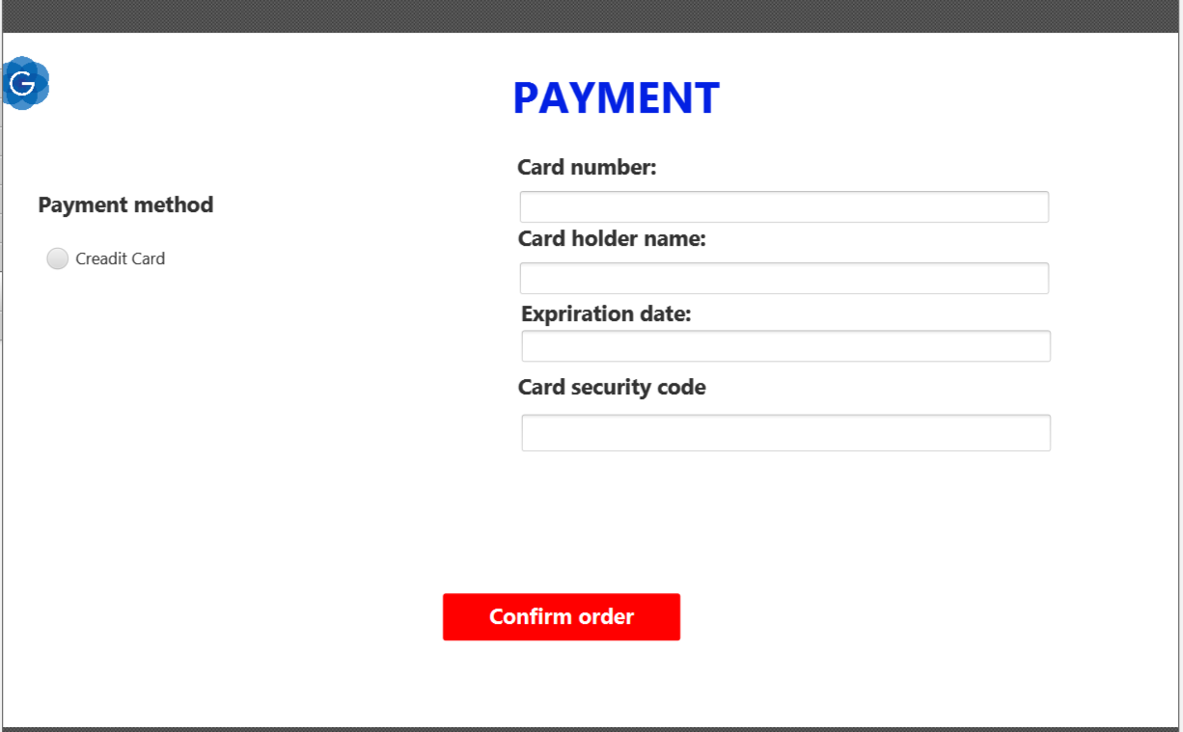 | Control | Operation | Function
 | Area for displaying the Payment method | Click | Client chooses method payment
 | Area for displaying the information card | Click  Input | Client enter Card information
 | Title | Initial | Display name
 | Confirm button | Click | Confirm the order

Screen name | Payment
Item name | Number of digits(bytes) | Types | Field attribute | Remarks
Card holder name | 50 | String | Black
Card number | 50 | Numeral | Black
Expiration date | 50 | String | Black
Card security code | 50 | Numeral | Black

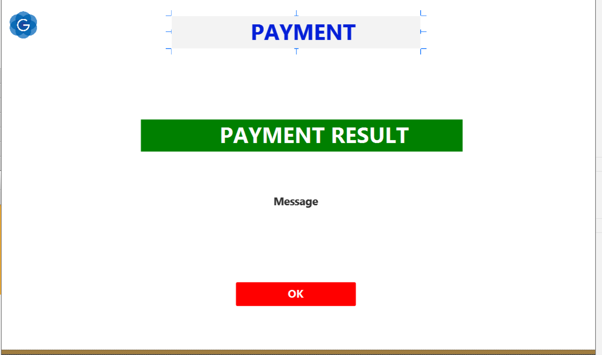 | Control | Operation | Function
 | Area for displaying the  message | Click | Display Result
 | Title | Initial | Display name
 | Confirm button | Click | Confirm the Payment

Screen name | PaymentResult
Item name | Number of digits(bytes) | Types | Field attribute | Remarks
Message | 50 | String | Black

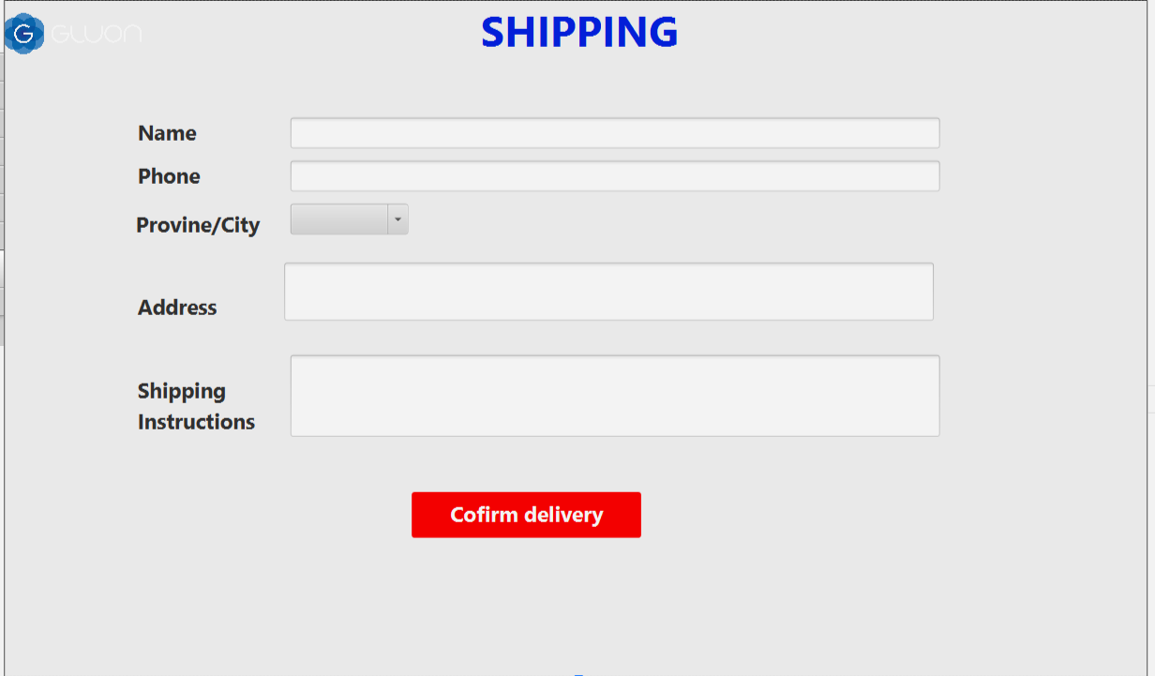 | Control | Operation | Function
 | Area for displaying the  Form input | Click,input | Client enter shipping information
 | Title | Initial | Display name
 | Chose Province | Click | Client Chosses Provice and city
 | Confirm button | Click | Confirm the Shipping

Screen name | Payment
Item name | Number of digits(bytes) | Types | Field attribute | Remarks
Name | 50 | String | Black
Phone | 50 | Numeral | Black
Address | 50 | String | Black
Shipping instructions | 50 | String | Black
Provine/City | 50 | Chose

